**OUTREACH SCHOOLS EXAMINATION BOARD**

 **END OF TERM II EXAMINATION 2024**

**MIDDLE CLASS: (4 – 5 YEARS)**

**LEARNING AREA 4: MATHEMATICAL CONCEPTS**

**My name is: ………………………………..………………………….**

**My School is: ……………………………..……….…………………..**

**I am in: ………………………………..…………………………………………..**

1. **Draw and write again.**

|  |  |  |  |
| --- | --- | --- | --- |
|  |  |  |  |
| star | oval | cone | square |
|  |  |  |  |
| star |  |  |  |

1. **Match and write numbers.**

6

l 6 __________

2 7 ____________

3 8 ____________

4 9 ____________

5 l0 ____________

6 l ____________

7 2 _____________

8 3 ____________

9 4 ______________

l0 5 ______________

1. **Count and match.**

4

5

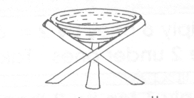

2

3

l

6

1. **Count the beads and write.**

6

= _______ = _______

= _____ = _______

= ______ = _______

**END**